**Steps Downloading, Installing and Configuring Visual Studio Code**

* **Visit the Official VS Code Website:**
* Open your web browser and navigate to the official Visual Studio Code website: <https://code.visualstudio.com/>.
* **Download the Installer:**
* Click on the "Download for Windows" button to download the latest stable release of Visual Studio Code.
* The website will automatically detect your operating system and offer the appropriate installer.
* Once the download is complete, locate the installer file (usually named something like VSCodeUserSetup-x64-<version>.exe) in your Downloads folder and double-click it to start the installation process.
  + When the installer window opens, click "Next" to proceed.
  + Read through the license agreement, then check the box to accept the terms and click "Next."
  + Choose the destination folder where you want to install VS Code. The default location is usually fine. Click "Next."
  + Choose any additional tasks you want to perform during installation. It is recommended to check the following options:
    - "Create a desktop icon"
    - "Add to PATH (requires shell restart)"
    - "Register Code as an editor for supported file types"
    - "Add 'Open with Code' action to Windows Explorer file context menu"
    - "Add 'Open with Code' action to Windows Explorer directory context menu"
  + Click "Next" after making your selections.
  + Click the "Install" button to begin the installation. The installer will copy the necessary files and set up VS Code on your system.
  + Once the installation is complete, you will see a "Setup was successful" message. Check the box to "Launch Visual Studio Code" if you want to start VS Code immediately, and then click "Finish."
  + Clicking the VS Code icon on your desktop.
  + Searching for "Visual Studio Code" in the Start menu and selecting it.
    - 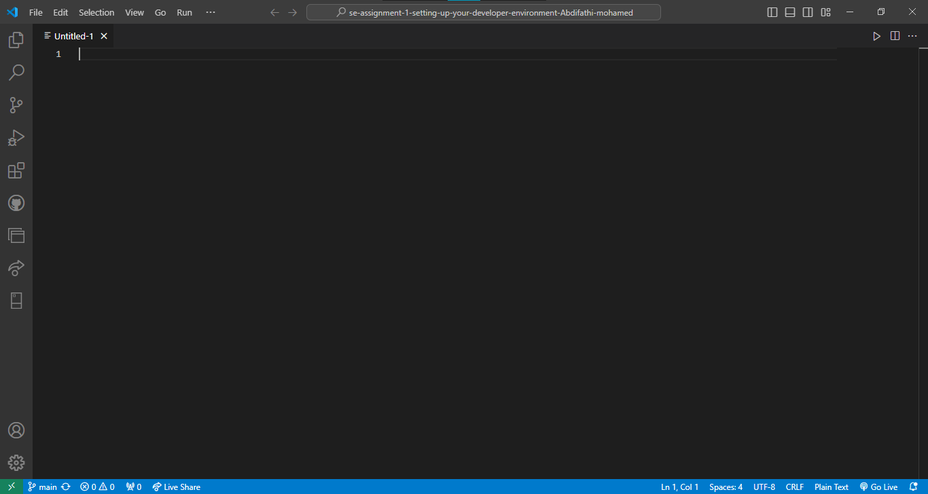
* **Set Up Extensions**
* **Open the Extensions View:**
* Click on the Extensions icon in the Activity Bar on the side of the window (it looks like a square with four squares inside it), or use the keyboard shortcut Ctrl+Shift+X.
* **Install Essential Extensions:**
* Search for and install any extensions you might need for your development work, such as:
  + - **Python:** Adds support for Python programming.
    - **Prettier - Code Formatter:** Automatically formats your code.
    - **Live Server:** Launches a local development server with live reload.
    - **Dart:** supports for dart programming.
    - 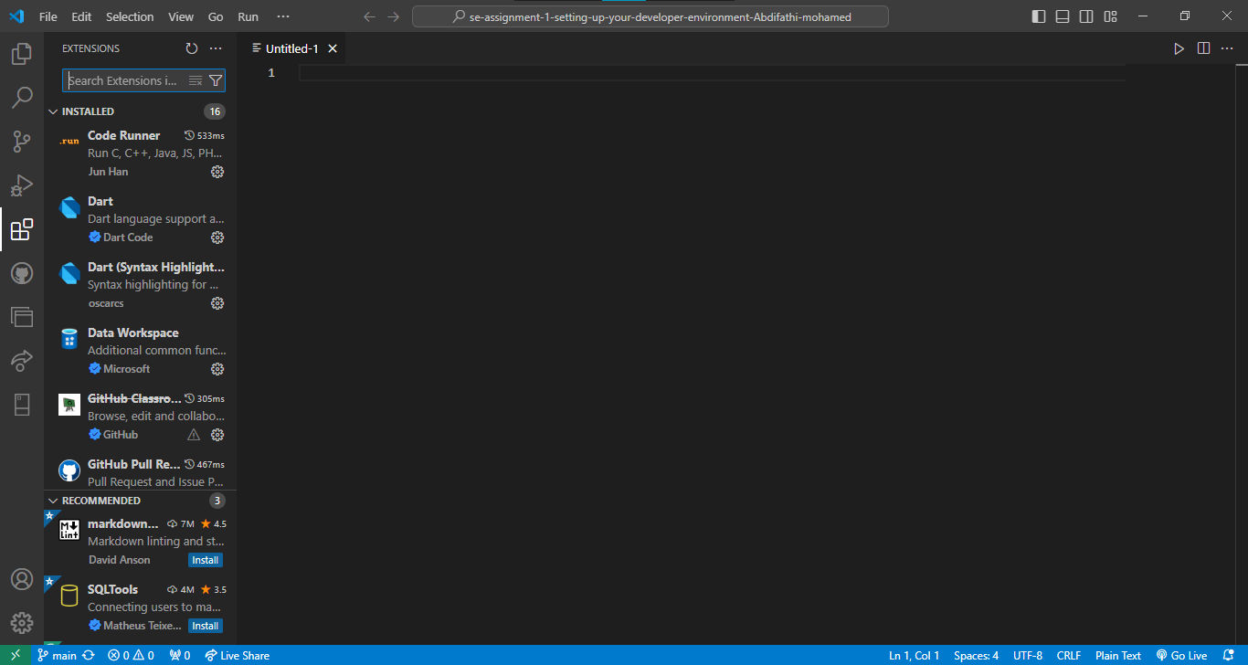
    - 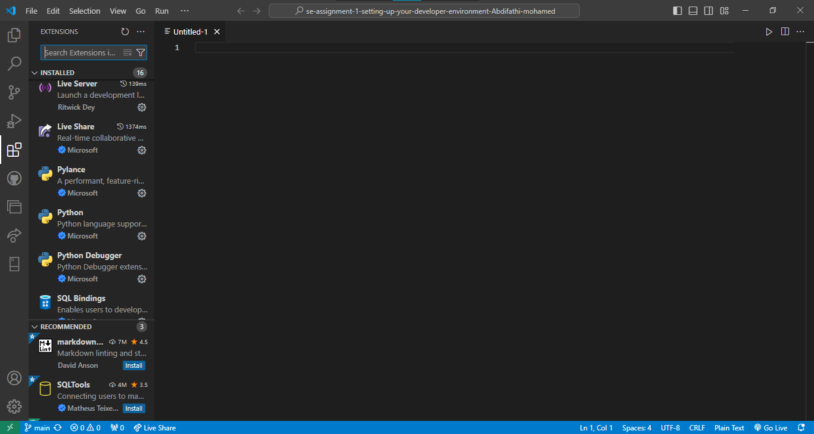
* **Configure Settings**
* **Open Settings:**
* Go to File > Preferences > Settings or use the keyboard shortcut Ctrl+, to open the settings.
* **Adjust Settings:**
* Customize VS Code settings according to your preferences, such as editor font size, theme, and workspace settings.

